NCCCLA District 3 met in person on June 25, 2025 with twelve library staff from across the district assembling in the library at Alamance Community College in Graham NC.

Debra McMusker, Alamance Community College Information Technology & Artificial Intelligence Instructor and Department Head presented on “AI in the Community College: Faculty and Librarians — Essential Partners” about the new landscape of AI in community colleges and how librarians are valued partners in that endeavor.

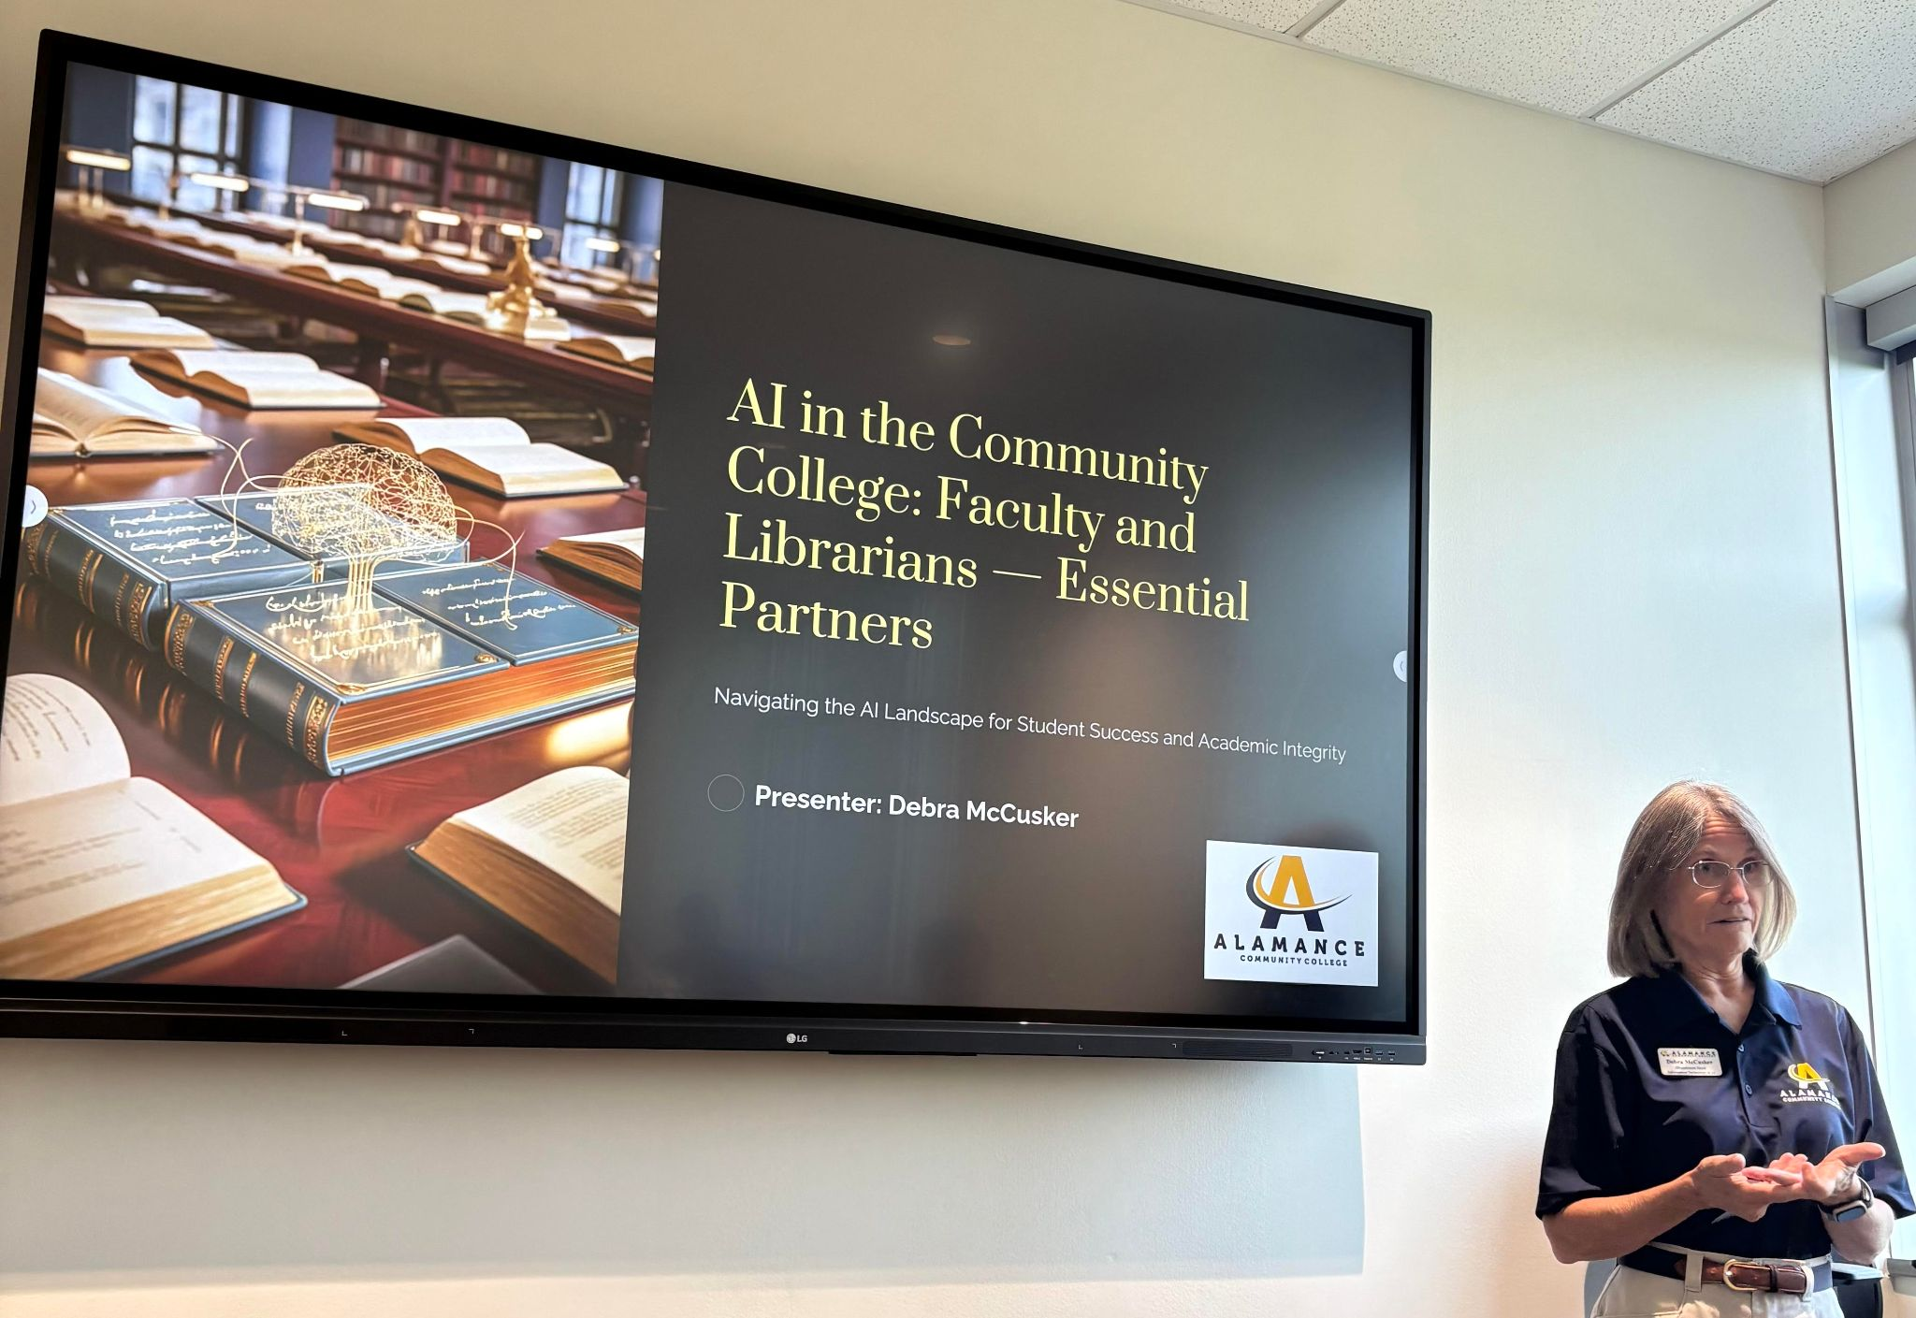

Slides attached.

Sophie Hollis and Devon Waugh from NC Live presented about NC LIVE usage stats and what to do with them, marketing resources based on usage data, and an overview of the top nursing and business NC Live resources.

NC Live Slides: https://docs.google.com/presentation/d/1RyuR3DpZQc-P7mD_4EFDEo_67HfcCtyABr_XdHGH624/edit?usp=sharing

Partnering in Ai slides: https://ncccla.wordpress.com/wp-content/uploads/2025/06/partnering-in-ai-faculty-and-library.pdf

