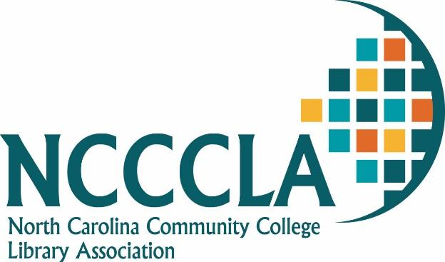
Achievement Award Guidelines

The Achievement Award is presented to a member of NCCCLA who has made a significant contribution to the library profession.
Final selection of recipients is made by the Awards Committee and is based on one or more of the following criteria:
- Development of a project that significantly benefits the library profession.
- Promotion of the profession through legislative work.
- Publication of material that contributes to the profession.
Guidelines for the application of the Award are:
- Nomination submitted by a member of NCCCLA.
- Three (3) letters of commendation from colleagues, employers or others who have knowledge of the nominee's work.
- Email the documents to the Awards Chairperson by July 31st of the conference year.
The Nominator should solicit the letters of commendation and mail the Nomination Form with the letters to the Awards Chairperson.
An Achievement Award Plaque is presented at the NCCCLA annual conference.

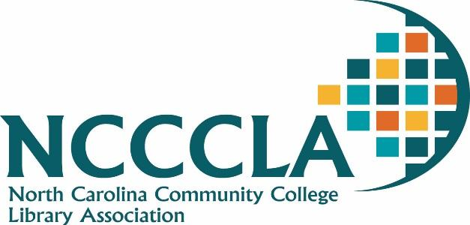
Nomination for Achievement Award

I hereby nominate the following person for the NCCCLA Achievement Award:

Name:
Institution:
Address:
City: State: Zip:

Which category best represents the area of contribution?
____ Development of a project that benefits the profession
____ Promotion of the profession through legislative work
____ Publication (give citation)

Please provide a short narrative description of the project, work, or publication. Include when and where the activity occurred and city documentation.

What impact has this work had on the learning resources profession?

Nomination made by:
Institution:
Address:
City: State: Zip:

Submit nomination and three (3) letters of commendation to:

Alisha M. Webb, MLIS
Library Director
Forsyth Technical Community College
2100 Silas Creek Parkway
Winston-Salem, NC 27103
336.728.7314
awebb@forsythtech.edu

