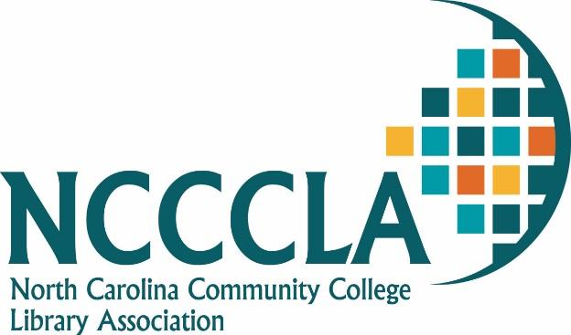

Life Membership Award Guidelines
The Life Membership Award is presented to a person who has retired or is retiring from a learning resource center, library, media center or individual learning center in the community college system of North Carolina or to a person who is in the Library Education profession. The Life Membership Award qualifies a person to be a life member of the NCCCLA. Life members are exempt from paying dues and have all the privileges of active members except that of holding elected office.

Application Guidelines for the Award are:
- Nomination submitted by a member of NCCCLA.
- Nominee has retired/is retiring from the NC Community College System or from the Library Education profession.
- Nominee was an active member of NCCCLA during his/her career.
- Email the documents to the Awards Chairperson.
A Life Membership Award certificate is presented at the NCCCLA annual conference.

Nomination for Life Membership Award

I hereby nominate the following person for the NCCCLA Life Membership Award:

Name:
Institution:
Address:
City: State: Zip:
Date of Retirement:

Comments:

Memberships and offices in professional organizations:

Publications:

Honors received:

Nomination made by:
Institution:
Address:
City: State: Zip:

Submit nomination to:

Alisha M. Webb, MLIS
Library Director
Forsyth Technical Community College
2100 Silas Creek Parkway
Winston-Salem, NC 27103
336-728.7314
awebb@forsythtech.edu

